# NETWORKING & SYSTEM ADMINISTRATION LAB

**Name:MELBIN M P**

**Roll No: 19**

**Batch: S2 RMCA B Date: 21-04-2022**

**Experiment No: 6**

# Aim

Familiarization of linux commands.

# Procedure

1. **Read command**

Used to read the contents of a line into a variable.

$ read [options][name] Output:



# Locate command

Locate command and find command is used to search a file by name. To locate a particular directory or file.

Find: not path specified it specifies if it exists or not.

# a) locate -i filename

Ignore case it is used to ignore case sensitivity of the specified patterns. Output:



$ find empty.txt Output:



# grep command

The ‘grep’ command stands “global regular expression print”. It will let you search through all the text in a given file.

$ grep <search word>filename Output:



# grep -i

This command filters output in a case-insensitive way.

$ grep -i <search word><filename> Output:



# grep -v

Command displays lines not matching to the specified word(inverted search). Output:



# grep -A1

This command is used to display the line after the result. Output:



# grep -B1

This command is used to display the line before the result.



# grep -C1

This command is used to display the line after and line before the result. Output:



# df command

Command used to display the disk space used in the file system(df – disk file system).

# a) df -m

To see the reports in megabytes. Output:

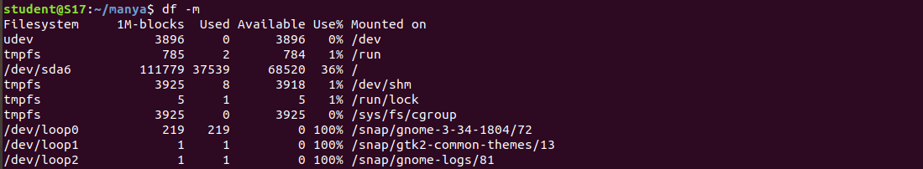

# du command

du stands for disk usage, to check how much space a file or directory takes. Output:



# wc command

Helps to counting the lines, words and characters in a file.

1. $ wc -l filename

It displays the number of lines Output:



1. $ wc -w filename

It displays the number of words Output:



1. $ wc -c filename

It displays the number of characters Output:



1. $ wc -m filename

It displays number of bytes. Output:

